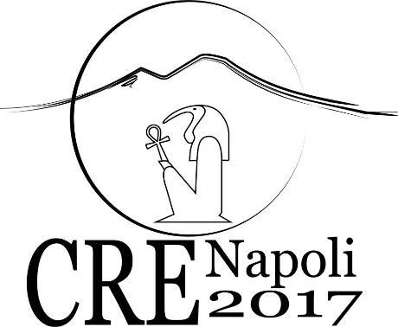

REGISTRATION FORM

FIRST NAME .…………………………………………………………………………
LAST NAME ………………………………………………………………………….
COUNTRY …………………………………………………………………………….
ORAL SESSION or POSTER PRESENTATION …………………………………….
EARLY or LATE REGISTRATION ………………………………………………….

IBAN: | IT 53 G010 1003 5931 0000 0301499
BENEFICIARY: | Università degli Studi di Napoli “L’Orientale”
ADDRESS OF THE BENEFICIARY: | Via Chiatamone, 61/62 – 80121 (Napoli)
PAYMENT PURPOSE: | CRE 2017 Naples
BIC / SWIFT | IBSPITNA
BANK ADDRESS | Via Forno Vecchio, 36 (Napoli)

N.B. Please remind to send to cre2017naples@gmail.com the payment receipt and this form completed

